Israel Peace Alternatives invites you to meet the author:
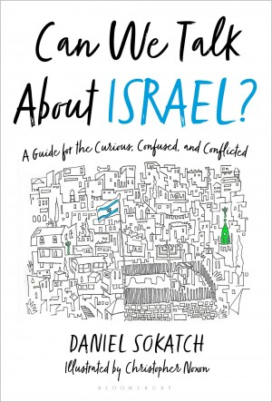
Join us on Zoom or at Congregation B'nai Israel, 3600 Riverside Blvd., Sacramento, on Thursday October 20, 2022, at 7 pm, for a conversation with Daniel Sokatch, author of Can We Talk About Israel: A Guide for the Curious, Confused, and Conflicted and CEO of the New Israel Fund. Sokatch’s book explores why so many people feel so strongly about Israel and the Israeli-Palestinian conflict. Why does this issue alone turn some classic Jewish liberals into uber-conservatives? Why do compassionate and judicious intellectuals single Israel out for boycotts, sanctions, and a level of opprobrium they do not apply to the dozens of other state actors out there? Why do Evangelical Christians who have never even met actual Jews, or for whom Jews are basically souls to be saved, feel such fierce loyalty towards Israel? Why does it sometimes seem like Israel is the answer to “what’s wrong with the world” for half of the people in it, and “what’s right with the world” for the other half?

Please register to attend in person or for the link to attend by Zoom.
https://www.cbisacramento.org/event/lll-program--guest-speaker-daniel-sokatch-.html

To purchase the book, visit HERE or your local bookstore
https://www.bloomsbury.com/us/can-we-talk-about-israel-9781635573879/

Daniel Sokatch has served as the CEO of the New Israel Fund, which was founded in San Francisco, since 2009. During the past decade of extraordinary challenges, NIF has risen to new heights as the great defender of justice, democracy, and equality in Israel. Before joining NIF, Daniel served as the Executive Director of the Jewish Community Federation of San Francisco, the Peninsula, Marin and Sonoma Counties. Daniel holds an MA from the Fletcher School at Tufts University, a JD from Boston College Law School, and a BA from Brandeis University.
ABOUT NIF:
The New Israel Fund is the leading organization advancing and defending democracy in Israel. More info: NIF.org.
COSPONSORS: Social Action Committee of Congregation Bet Haverim ; Israel Committee and Lifelong Learning Committee of Congregation B’nai Israel; J Street Sacramento Region
The views expressed by this program, the speaker, or the speaker's sponsoring organization are not necessarily the views of Congregation Bet Haverim. Our congregation is committed to honoring the diversity of thoughts and opinions within our community.

