CBH Survey (May 2021)
The survey was provided to CBH Partners to help inform the drafting of the CCAR application. 136 partners responded to the survey.
Your CBH Experience
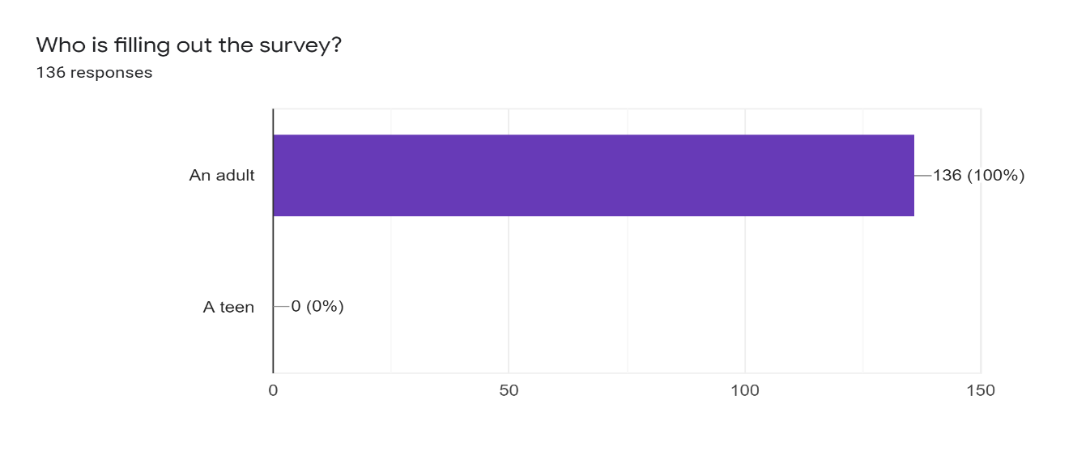
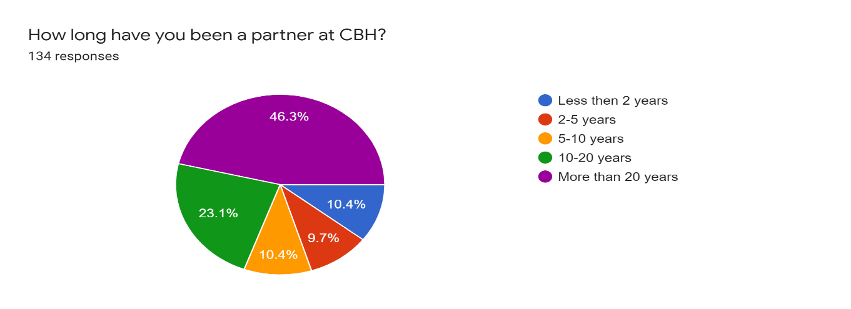
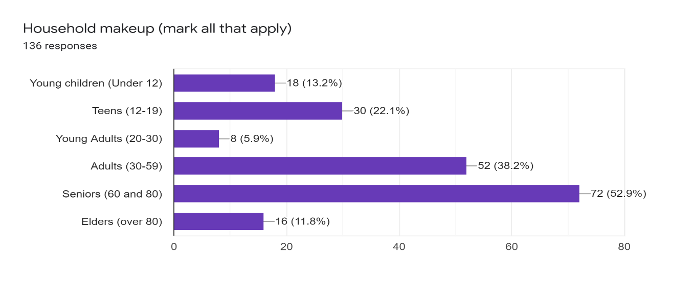

Additional responses:
- 4 grandkids visit two are school aged
- All children on their own in other households
- all grown up and away
- Both children are away now.
- My adult children who were bnai mitzvah'd at CBH are out of the house... living well... here and there...

Additional responses:
- I do a little work for CBH
- Shabbat Song Leaders
- Informal personal connection
- Israel Matters

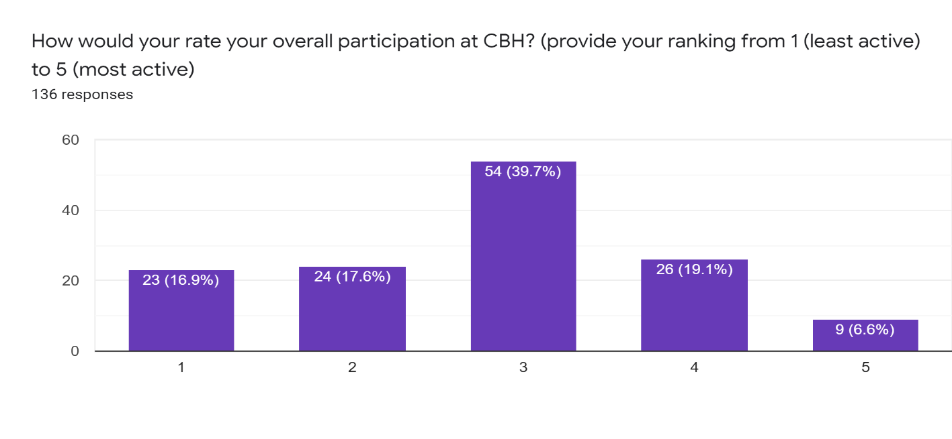
Rabbi Qualities and Skills
Options provided on the survey:
- Welcoming: Warm, accessible, and approachable to all partners
- Embracing: Makes people feel included and accepted for who they are (as Jews; interfaith families; seeking to convert)
- Charismatic: Brings positive energy and engaging attitude
- Mediator: Bridges different perspectives to support diversity and fosters an inclusive culture within CBH
- Diplomatic: Welcomes different views expressed by others regardless of personal ideology
- Collaborator: Promotes genuine trust and partnership and works well with volunteers, staff, and community leaders
- Authentic: Being true to themselves and their personal ideology
- Advocate: Be a voice of the Jewish community in the broader local community
- Activist: Promotes social and racial justice actions
- Youth-oriented: Connects and engages with children, youth, teens, and young families
- Innovative Leader: Has a vision to lead us into the future and brings new ideas to energize our community
- Musical: Has a good singing voice; Uses music to inspire and enhance our spiritual practice
- Pulpit skills: Delivers inspiring services and thought-provoking sermons about local, global, and Jewish issues
- Educator and Scholar: Intellectual, deep thinker, and dynamically engages partners in Jewish learning
- Pastoral skills: Skilled in providing solace, empathic counseling, and support to CBH partners
- Administrator: Manages effectively to support his/her role and congregation needs
- Fundraiser: Actively builds connections with partners and donors to create an environment that makes people want to fund a legacy to CBH
- Builder: Willing to reach out to Jews who are NOT CBH partners to build membership

Additional responses:
- Strongly support Israel
- Unwavering support for Israel as a Jewish state
- Connection to spiritual side of Judaism
- brings a sense of spirituality to services and elsewhere
- Able to counsel survivors (my age showing here)
- warm and welcoming attitude to Israelis and Israel

Top Future Priorities for Our Congregation

Additional responses:
- Provide opportunity for engagement along mutual interests.
- enhancing financial stability includes retaining & expanding partnership
- Ability to occasionally blend more Reform with Conservative in services.
- meaningful and affordable Jewish religious education for our children

Additional Input
- Let’s find someone warm, energetic, funny, kind, and preferably female.
- Good questions, good choices.
- Please more opportunities to study Jewish mysticism
- Personal qualities of Rabbi outweigh all others-his/her ability to relate to, connect to, and support congregants in all sorts of times and situations, in a genuine way, is essential. It also helps this very disparate and contentious congregation keep strife from becoming overwhelming.
- The current participation in worship services is low. Despite that, I hope the Search Committee recognizes that worship is a crucial part of a congregation's function and purpose. A member may come to Shabbos services only once in 15 years - a yahrzeit or other personal reason - and we want to be there at that moment. There are other reasons of course - I am concerned that this critical element of Jewish life will not be given sufficient priority in this transition process. Also, I think our adult membership is generally not very knowledgeable about Judaism and I would like to see more educational opportunities and participation.
- I want Rabbi Greg. But failing that, we need a rabbi like him--kind, loving, empathetic--the kind of Jew you want to be around. Someone who can sing and who brings their intellectual and vast knowledge of Judaism to the fore. Someone who is always happy to see you and your family and remembers things about you. Who leads services like they really mean it. Who brings joy because they truly feel it. Also: I am a regular attendee at the Saturday minyan and it has been very difficult to see how dismissive this process has been about the importance of Saturday services to us-- how people who never come to services feel entitled to tinker with something they know nothing about and ruining a tradition that has stood for 50 years.
- Good questions for us. We already score high on many of the areas.
- A friendly, engaging and informed person with a commitment to helping others.
- The quality I have most valued in our rabbi is his long knowledge and affection for us in spite of ourselves. I did count on his ability to help my family in time of crisis, and it is what I will miss in anyone new, however skilled and willing. At my age this is a big loss. I will hope that whomever is chosen will continue the tradition, and realize that I must do my part to bring about a good future relationship. Both the young and the old are important to a congregation, but the young may be more likely to benefit from the change.
- Focus on culture, inspiring younger generation, maintaining Jewish connection, building community engagement
- I didn't choose the option earlier, but having someone 100% accepting of interfaith families is very important to me. Also charisma and making everyone feel welcome is also important. Thanks for all you're doing helping with this transition!
- Thank you for the opportunity to participate in this process.
- Want a rabbi who is an excellent speaker who draws us back to temple week after week. Want a message that is not just a retelling of the Torah portion, but also relates to our everyday lives today. It is crucial to us that the rabbi be a strong supporter of progressive ideas and values. We want a reason to become more engaged with the temple. Even before Covid we found it difficult to find our niche as newcomers to the community. Unless you have children it is hard to become engaged if you have no friends or family at the temple. I wish there was an active Sisterhood and Brotherhood. I hope the Rabbi will champion more opportunities for people to socialize, volunteer and create friendships outside of services.
- Someone who takes great pride in their Jewish identity and whose Jewish identity is a priority in their life. A rabbi who doesn't apologize for being too Jewish despite the diversity of the synagogue membership. Someone who believes that everyone who shows up has a Jewish soul, regardless of Halacha, and doesn't water down Judaism to appeal to those who are new to the religion. A rabbi who understands that people connect differently to Judaism and their Jewish identity and provides opportunities for engagement in a number of ways equally. Someone who can appeal to Jews across denominations despite the synagogue's affiliation with URJ.
- Without full-time cantor, it would be nice to have a musical rabbi
- Thank you for putting together such a thoughtful and engaging process. Your efforts are appreciated!
- My biggest concern is that it is expensive and time consuming to educate kids, in Hebrew and on Jewish religion or history. I don't want my kids to only have a vague sense of Judaism as something that's separated from the rest of their lives. good pedagogy and support from the community in terms of programming, funding, etc., will be invaluable to me.
- The most important thing in a rabbi is to be a nice person - everything else is, as they say, commentary
- Someone with good Hebrew language skills
- Very much hoping the next rabbi will be able to engage with and integrate difficult current events (climate change, social justice) during services in a way that encourages action and helps facilitate our CBH community being “part of the solution.” Someone who will lead and create opportunities for others to participate and co-lead, in line with our Jewish traditions and values. I would be more likely to join in activities when I feel like I am grappling with the big problems and like my Judaism is relevant to my secular life.
- Dealing with our diverse congregation in a way that makes all feel welcome and heard is by far the most important quality.
- I would prefer a female rabbi
- I’d like a rabbi who’s a person of color
- It is important to find a rabbi who is inspiring!
- Young rabbi who is dedicated to welcoming a diverse community & genuinely involved in tikkun olam. Not stuck in traditional rabbinic role, not dictator of religious behavior, presents collaborative & creative energy
- Music and spiritual uplift to services
- I'd like to see more interest and inclusion of Hebrew and meaningful prayer as a way to connect to Judaism in addition to the social and political emphasis that CBH offers.
- I hope we get a nice rabbi like Rabbi Greg has been! Otherwise, I will probably drop my membership here and join Bnai Israel in Sacramento.
- I hate to say this, but I can't see this survey being useful -- If I could have, I'd check most of the boxes. There is a lot of overlap in the categories -- "welcoming" versus "inclusive" versus "tolerance" etc. We need to attend to almost every item mentioned, and we need a Rabbi to partner with us on all of the above.
- Hopefully more interaction at live in house services once they are available and safe.
- My thanks to the Search Committee for all your hard work and dedication to this process!
- Can’t think of anything else.
- Being limited to 5 responses to each question is very difficult. I also think it is critical that the new rabbi be diplomatic and has good pulpit and pastoral skills.
- Currently the community is very age-segregated. My hope is that the new rabbi set the tone that we are all one big tent community. Children would be welcomed to services, even if they are loud and fidget. While some differentiated services could be offered for those who are more reform and those who are more conservative, several services throughout the year would be for everyone to create a sense of connection. The new rabbi should cater equally to older congregants, students, or families with children, regardless of who is financially sustaining the organization. The financial sustainability of the organization should NOT be the rabbi’s role, although she/he/they should assist where needed. The rabbi needs to be open to interfaith families and comfortable with congregants who are not pro-Israel or feel any connection to Israel.
- Why is Israeli Politics called out in survey but not US Politics? We are an American congregation, and we need to pray for OUR government, as it says in Pirke Avot... I would guess many in congregation would appreciate "less" Israel politics at CBH as it's such a divisive Issue. This would reflect what National Survey's show: an increasing alienation from State of Israel, especially by young Jews, the next generation, but there was no option for on survey for many of us to share this sentiment. On inclusiveness/ divisiveness; . The biggest fights at CBH are about Israel, so when people say in survey they want it more inclusive they many might be saying they want LESS Israel. For example, Inclusivity might reflect concern we DO NOT have speakers in from groups who leaders are anti-LGBTQ.... just because the support the State of Israel.
- As a still working (not retired) senior who is single, I haven’t felt included by CBH. My young adult daughter feels the same way. We haven’t felt included by CBH since she finished religious school/ Bat Mitzvah at 13yo. We volunteered at the Rotating Homeless Shelter multiple times every year because we care about our community, and we wished (and still wish) that CBH would offer us a sense of community, too.
- offering classes enriching our appreciation of our Jewish heritage and continue the Torah study on Shabbat.
- Looking for an inspirational as well as authentic individual who reaches out to collaborate with members of congregation and wider community. Looking for someone who will bring people together as well as lift them up spiritually.
- Thank you for your time and energy, Search Committee!
- Thank you for this opportunity to connect.
- Most items on the list of desired traits are important. Welcoming and inclusive mensch with a good voice and creative ideas for programming and expanding/retaining members is most important
- I note 2 Survey questions on Israel programs, nothing on the holocaust, and nothing on American Jewish Life. I suggest blind spots for those who made up survey as to ways to be Jewish.
- For many years I was intensely involved with CBH as a co-president, board member, social action committee member, Hebrew student. Now I'm mostly involved as a member of the social action committee. My spouse attends holiday celebrations.
- I am very happy with Rabbi Greg Wolfe and believe that we would be well served by a person with similar traits.
- For the first set of FIVE choices... I found similar questions there hard to choose between so for those I list them below as I chose the first in each group. mediator vs diplomatic warm vs embracing... and builder educator vs pulpit skills in Future FIVE question section . INCLUSIVITY... was asked in several ways and I did not choose any - so I could choose some others... because I know there is a lot of work being done by volunteers on this issue AND I strongly believe we are currently a very welcoming congregation AND THEN...The question about Expanding across life stage and Enhancing youth programs left me, as an older adult -- going with the "generic" Expanding question as I saw youth being included in that. AND the two questions about Israel gave me some pause since as a people I see non-politics and politics relative to Israel and Jews as intimately intertwined... and very difficult to separate... even while consensus may be difficult to come to... I chose the non-political option
- As I think of my perfect rabbi, I don't really think about life at the synagogue. I think about someone who would be willing to take me out for tea/coffee and offer a little wisdom when I needed it.
- Would love to see activity growth plans include spiritually strengthening marriage classes for members, including gender support groups, and spiritual relationship skills classes to draw in, support, and engage college students-early adults.

