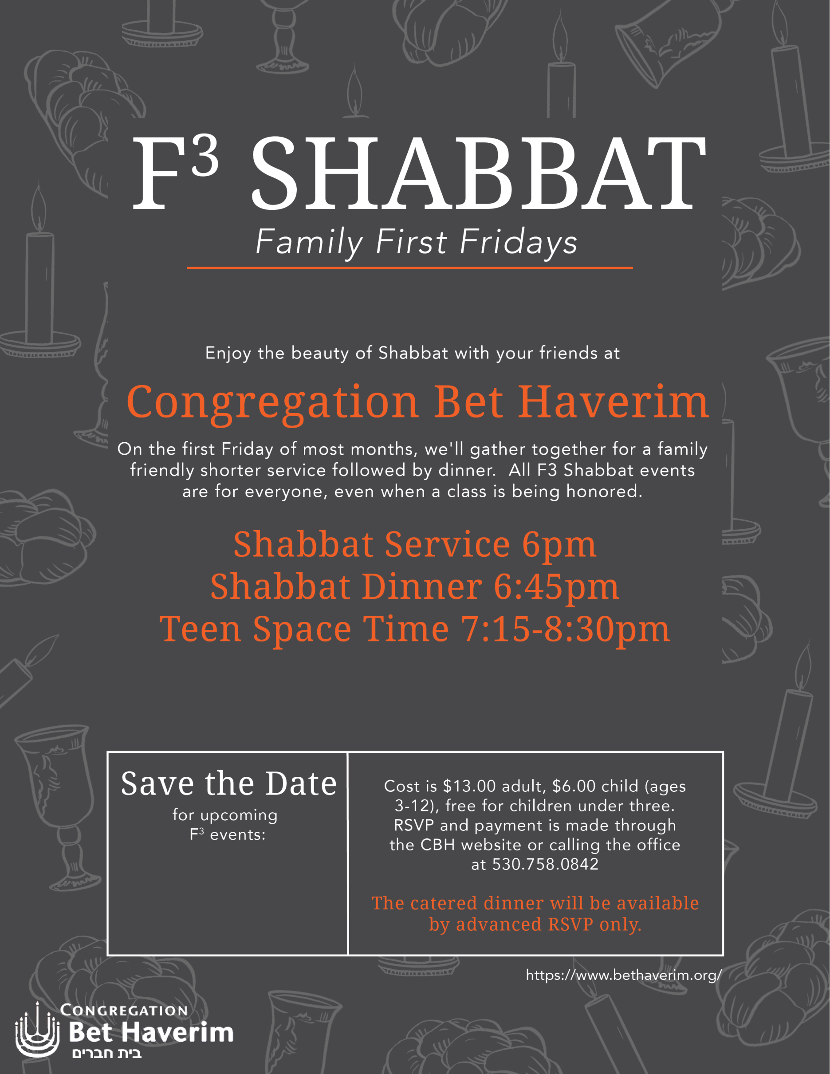

December 6th: Fifth Grade

February 7th: Sixth Grade

March 6th: Third Grade

April 3rd: Fourth Grade

May 1st: Seventh Grade

More information about catering for the November F3 Shabbat

will be available soon.

November 1, 2019; Honoring our Second Grade Students